EXPERIMENT- 07
Capture Video from Web Camera and Display the Video
Aim
To write a Python code to capture live video from the webcam and display the video frames using OpenCV.
Input
Web Camera
Code
import cv2
cap=cv2.VideoCapture(0)
if not cap.isOpened():
print("Error: Could not open camera")
else:
while True:
ret,frame=cap.read()
if not ret:
break
cv2.imshow("Webcam Video",frame)
if cv2.waitKey(1)&0xFF==ord('q'):
break
cap.release()
cv2.destroyAllWindows()

Output
Webcam Video Display
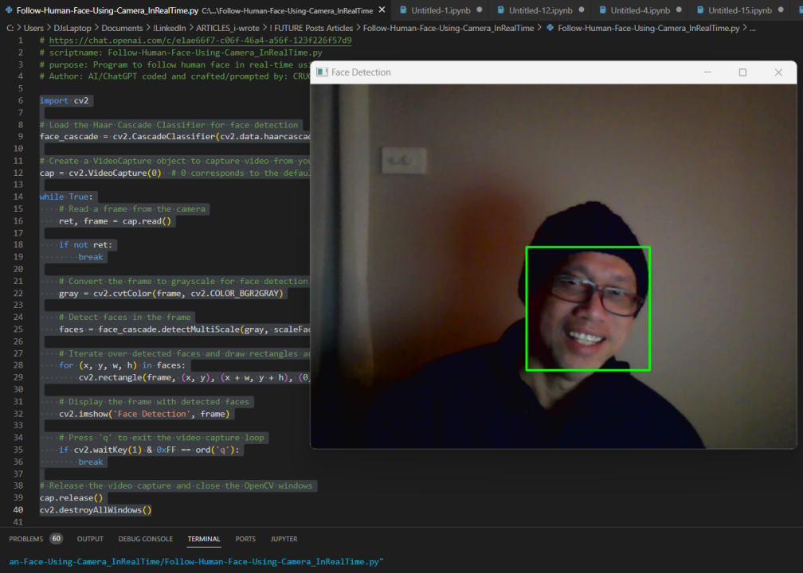
Result
Thus, the webcam video was successfully captured and displayed using OpenCV.

